***In Silico* evaluation and drug-likeness prediction of some thiadiazole derivatives as ULK1/2 inhibitors**

Parin Sidat1,2*, Malleshappa Noolvi2, Sanket Rathod3, Rahul Patil4, Prafulla Choudhari3, Raj Wagh 5, Vishal Beldar6

1PhD Scholar, Pharmacy branch, Gujarat technological University, Ahmedabad, Gujarat, India

2Department of Pharmaceutical Chemistry, Shree Dhanvantary Pharmacy College, Kim-394110, Gujarat, India.

3Department of Pharmaceutical Chemistry, Bharati Vidyapeeth College of Pharmacy, Kolhapur, 416 013 (MS), India.

4Department of Pharmaceutics, Shree Dhanvantary Pharmacy College, Kim-394110, Gujarat, India.

5Department of Chemical Engineering, Institute of Chemical Technology Mumbai, Marathwada Jalna.

6Department of Pharmacognosy, Institute of Chemical Technology Mumbai, Marathwada Jalna.

**Supplementary Information**

**Table of Contents**

1. **Supplementary Figure S1………………………………………….…………...…2**
2. **Supplementary Table S1………………………………………………………….3**
3. **Supplementary Table S2 …………………………………………………………4**
4. **Supplementary MD simulation video S1 (Compound 4WNP-4D) ...………....10**
5. **Supplementary Figure S2……………………………………….…..…………..10**
6. **Analytical Supplementary Data …………………………………………………….11**

**Supplementary Figure S1: Complete synthetic scheme of proposed derivatives**



**Supplementary Table S1: Complete details of proposed derivatives with their codes**

|  |  |  |  |  |  |  |  |  |
| --- | --- | --- | --- | --- | --- | --- | --- | --- |
| **Code** | **R1** | **Code** | **R1** |  | **Code** | **R2** | **Code** | **R2** |
| **1** | H | **5** | CH3 | **a** |  | **e** |  |
| **2** | OH | **6** | OCH3 | **b** |  | **-** | - |
| **3** | Cl | **7** | Br | **c** |  | **-** | - |
| **4** | F | **8** | NO2 | **d** |  | **-** | - |
| **Proposed Molecule** | | | | | | | | |

**Supplementary Table S2: IUPAC names of the proposed derivatives with their SMILES [1(a-e) to 8(a-e)]**

|  |  |  |  |  |  |
| --- | --- | --- | --- | --- | --- |
| **Sr. No.** | **Code** | **IUPAC Name** | **MF** | **SMILES** |  |
| 1 | 1a | N2-(1-allyl-1H-benzo[d]imidazol-6-yl)-N4-(5-phenyl-1,3,4-thiadiazol-2-yl)-4a,8a-dihydroquinazoline-2,4-diamine | C26H22N8S | C=CCn1cnc2ccc(cc21)NC=1N=C(Nc2nnc(s2)c2ccccc2)C2C=CC=CC2N=1 |  |
| 2 | 1b | N2-(2-aminophenyl)-N4-(5-phenyl-1,3,4-thiadiazol-2-yl)-4a,8a-dihydroquinazoline-2,4-diamine | C22H19N7S | Nc1ccccc1NC=1N=C(Nc2nnc(s2)c2ccccc2)C2C=CC=CC2N=1 |  |
| 3 | 1c | N4-(5-phenyl-1,3,4-thiadiazol-2-yl)-N2-(pyrimidin-2-yl)-4a,8a-dihydroquinazoline-2,4-diamine | C20H16N8S | N=1C(Nc2ncccn2)=NC2C=CC=CC2C=1Nc1nnc(s1)c1ccccc1 |  |
| 4 | 1d | N2-(4-fluorophenyl)-N4-(5-phenyl-1,3,4-thiadiazol-2-yl)-4a,8a-dihydroquinazoline-2,4-diamine | C22H17FN6S | Fc1ccc(cc1)NC=1N=C(Nc2nnc(s2)c2ccccc2)C2C=CC=CC2N=1 |  |
| 5 | 1e | 2-((4-((5-phenyl-1,3,4-thiadiazol-2-yl)amino)-4a,8a-dihydroquinazolin-2-yl)amino)ethanol | C18H18N6OS | OCCNC=1N=C(Nc2nnc(s2)c2ccccc2)C2C=CC=CC2N=1 |  |
| 6 | 2a | 4-(5-((2-((1-allyl-1H-benzo[d]imidazol-6-yl)amino)-4a,8a-dihydroquinazolin-4-yl)amino)-1,3,4-thiadiazol-2-yl)phenol | C26H22N8OS | C=CCn1cnc2ccc(cc21)NC=1N=C(Nc2nnc(s2)c2ccc(O)cc2)C2C=CC=CC2N=1 |  |
| 7 | 2b | 4-(5-((2-((2-aminophenyl)amino)-4a,8a-dihydroquinazolin-4-yl)amino)-1,3,4-thiadiazol-2-yl)phenol | C22H19N7OS | Nc1ccccc1NC=1N=C(Nc2nnc(s2)c2ccc(O)cc2)C2C=CC=CC2N=1 |  |
| 8 | 2c | 4-(5-((2-(pyrimidin-2-ylamino)-4a,8a-dihydroquinazolin-4-yl)amino)-1,3,4-thiadiazol-2-yl)phenol | C20H16N8OS | Oc1ccc(cc1)c1nnc(NC2=NC(Nc3ncccn3)=NC3C=CC=CC23)s1 |  |
| **9** | 2d | 4-(5-((2-((4-fluorophenyl)amino)-4a,8a-dihydroquinazolin-4-yl)amino)-1,3,4-thiadiazol-2-yl)phenol | C22H17FN6OS | Fc1ccc(cc1)NC=1N=C(Nc2nnc(s2)c2ccc(O)cc2)C2C=CC=CC2N=1 |  |
| 10 | 2e | 4-(5-((2-((2-hydroxyethyl)amino)-4a,8a-dihydroquinazolin-4-yl)amino)-1,3,4-thiadiazol-2-yl)phenol | C18H18N6O2S | Oc1ccc(cc1)c1nnc(NC2=NC(NCCO)=NC3C=CC=CC23)s1 |  |
| 11 | 3a | N2-(1-allyl-1H-benzo[d]imidazol-6-yl)-N4-(5-(4-chlorophenyl)-1,3,4-thiadiazol-2-yl)-4a,8a-dihydroquinazoline-2,4-diamine | C26H21ClN8S | C=CCn1cnc2ccc(cc21)NC=1N=C(Nc2nnc(s2)c2ccc(Cl)cc2)C2C=CC=CC2N=1 |  |
| 12 | 3b | N2-(2-aminophenyl)-N4-(5-(4-chlorophenyl)-1,3,4-thiadiazol-2-yl)-4a,8a-dihydroquinazoline-2,4-diamine | C22H18ClN7S | Nc1ccccc1NC=1N=C(Nc2nnc(s2)c2ccc(Cl)cc2)C2C=CC=CC2N=1 |  |
| 13 | 3c | N4-(5-(4-chlorophenyl)-1,3,4-thiadiazol-2-yl)-N2-(pyrimidin-2-yl)-4a,8a-dihydroquinazoline-2,4-diamine | C20H15ClN8S | Clc1ccc(cc1)c1nnc(NC2=NC(Nc3ncccn3)=NC3C=CC=CC23)s1 |  |
| 14 | 3d | N4-(5-(4-chlorophenyl)-1,3,4-thiadiazol-2-yl)-N2-(4-fluorophenyl)-4a,8a-dihydroquinazoline-2,4-diamine | C22H16ClFN6S | Fc1ccc(cc1)NC=1N=C(Nc2nnc(s2)c2ccc(Cl)cc2)C2C=CC=CC2N=1 |  |
| 15 | 3e | 2-((4-((5-(4-chlorophenyl)-1,3,4-thiadiazol-2-yl)amino)-4a,8a-dihydroquinazolin-2-yl)amino)ethanol | C18H17ClN6OS | Clc1ccc(cc1)c1nnc(NC2=NC(NCCO)=NC3C=CC=CC23)s1 |  |
| 16 | 4a | N2-(1-allyl-1H-benzo[d]imidazol-6-yl)-N4-(5-(4-fluorophenyl)-1,3,4-thiadiazol-2-yl)-4a,8a-dihydroquinazoline-2,4-diamine | C26H21FN8S | C=CCn1cnc2ccc(cc21)NC=1N=C(Nc2nnc(s2)c2ccc(F)cc2)C2C=CC=CC2N=1 |  |
| 17 | 4b | N2-(2-aminophenyl)-N4-(5-(4-fluorophenyl)-1,3,4-thiadiazol-2-yl)-4a,8a-dihydroquinazoline-2,4-diamine | C22H18FN7S | Nc1ccccc1NC=1N=C(Nc2nnc(s2)c2ccc(F)cc2)C2C=CC=CC2N=1 |  |
| 18 | 4c | N4-(5-(4-fluorophenyl)-1,3,4-thiadiazol-2-yl)-N2-(pyrimidin-2-yl)-4a,8a-dihydroquinazoline-2,4-diamine | C20H15FN8S | Fc1ccc(cc1)c1nnc(NC2=NC(Nc3ncccn3)=NC3C=CC=CC23)s1 |  |
| **19** | 4d | N2-(4-fluorophenyl)-N4-(5-(4-fluorophenyl)-1,3,4-thiadiazol-2-yl)-4a,8a-dihydroquinazoline-2,4-diamine | C22H16F2N6S | Fc1ccc(cc1)NC=1N=C(Nc2nnc(s2)c2ccc(F)cc2)C2C=CC=CC2N=1 |  |
| **20** | 4e | 2-((4-((5-(4-fluorophenyl)-1,3,4-thiadiazol-2-yl)amino)-4a,8a-dihydroquinazolin-2-yl)amino)ethanol | C18H17FN6OS | Fc1ccc(cc1)c1nnc(NC2=NC(NCCO)=NC3C=CC=CC23)s1 |  |
| 21 | 5a | N2-(1-allyl-1H-benzo[d]imidazol-6-yl)-N4-(5-(p-tolyl)-1,3,4-thiadiazol-2-yl)-4a,8a-dihydroquinazoline-2,4-diamine | C26H22N8S | C=CCn1cnc2ccc(cc21)NC=1N=C(Nc2nnc(s2)c2ccccc2)C2C=CC=CC2N=1 |  |
| 22 | 5b | N2-(2-aminophenyl)-N4-(5-(p-tolyl)-1,3,4-thiadiazol-2-yl)-4a,8a-dihydroquinazoline-2,4-diamine | C23H21N7S | Nc1ccccc1NC=1N=C(Nc2nnc(s2)c2ccc(C)cc2)C2C=CC=CC2N=1 |  |
| 23 | 5c | N2-(pyrimidin-2-yl)-N4-(5-(p-tolyl)-1,3,4-thiadiazol-2-yl)-4a,8a-dihydroquinazoline-2,4-diamine | C21H18N8S | Cc1ccc(cc1)c1nnc(NC2=NC(Nc3ncccn3)=NC3C=CC=CC23)s1 |  |
| 24 | 5d | N2-(4-fluorophenyl)-N4-(5-(p-tolyl)-1,3,4-thiadiazol-2-yl)-4a,8a-dihydroquinazoline-2,4-diamine | C23H19FN6S | Fc1ccc(cc1)NC=1N=C(Nc2nnc(s2)c2ccc(C)cc2)C2C=CC=CC2N=1 |  |
| 25 | 5e | 2-((4-((5-(p-tolyl)-1,3,4-thiadiazol-2-yl)amino)-4a,8a-dihydroquinazolin-2-yl)amino)ethanol | C19H20N6OS | Cc1ccc(cc1)c1nnc(NC2=NC(NCCO)=NC3C=CC=CC23)s1 |  |
| 26 | 6a | N2-(1-allyl-1H-benzo[d]imidazol-6-yl)-N4-(5-(4-methoxyphenyl)-1,3,4-thiadiazol-2-yl)-4a,8a-dihydroquinazoline-2,4-diamine | C27H24N8OS | C=CCn1cnc2ccc(cc21)NC=1N=C(Nc2nnc(s2)c2ccc(OC)cc2)C2C=CC=CC2N=1 |  |
| 27 | 6b | N2-(2-aminophenyl)-N4-(5-(4-methoxyphenyl)-1,3,4-thiadiazol-2-yl)-4a,8a-dihydroquinazoline-2,4-diamine | C23H21N7S | Nc1ccccc1NC=1N=C(Nc2nnc(s2)c2ccc(C)cc2)C2C=CC=CC2N=1 |  |
| 28 | 6c | N4-(5-(4-methoxyphenyl)-1,3,4-thiadiazol-2-yl)-N2-(pyrimidin-2-yl)-4a,8a-dihydroquinazoline-2,4-diamine | C21H18N8OS | COc1ccc(cc1)c1nnc(NC2=NC(Nc3ncccn3)=NC3C=CC=CC23)s1 |  |
| 29 | 6d | N2-(4-fluorophenyl)-N4-(5-(4-methoxyphenyl)-1,3,4-thiadiazol-2-yl)-4a,8a-dihydroquinazoline-2,4-diamine | C23H19FN6OS | Fc1ccc(cc1)NC=1N=C(Nc2nnc(s2)c2ccc(OC)cc2)C2C=CC=CC2N=1 |  |
| 30 | 6e | 2-((4-((5-(4-methoxyphenyl)-1,3,4-thiadiazol-2-yl)amino)-4a,8a-dihydroquinazolin-2-yl)amino)ethanol | C19H20N6O2S | COc1ccc(cc1)c1nnc(NC2=NC(NCCO)=NC3C=CC=CC23)s1 |  |
| 31 | 7a | N2-(1-allyl-1H-benzo[d]imidazol-6-yl)-N4-(5-(4-bromophenyl)-1,3,4-thiadiazol-2-yl)-4a,8a-dihydroquinazoline-2,4-diamine | C26H21BrN8S | C=CCn1cnc2ccc(cc21)NC=1N=C(Nc2nnc(s2)c2ccc(Br)cc2)C2C=CC=CC2N=1 |  |
| 32 | 7b | N2-(2-aminophenyl)-N4-(5-(4-bromophenyl)-1,3,4-thiadiazol-2-yl)-4a,8a-dihydroquinazoline-2,4-diamine | C22H18BrN7S | Nc1ccccc1NC=1N=C(Nc2nnc(s2)c2ccc(Br)cc2)C2C=CC=CC2N=1 |  |
| 33 | 7c | N4-(5-(4-bromophenyl)-1,3,4-thiadiazol-2-yl)-N2-(pyrimidin-2-yl)-4a,8a-dihydroquinazoline-2,4-diamine | C20H15BrN8S | Brc1ccc(cc1)c1nnc(NC2=NC(Nc3ncccn3)=NC3C=CC=CC23)s1 |  |
| 34 | 7d | N4-(5-(4-bromophenyl)-1,3,4-thiadiazol-2-yl)-N2-(4-fluorophenyl)-4a,8a-dihydroquinazoline-2,4-diamine | C22H16BrFN6S | Fc1ccc(cc1)NC=1N=C(Nc2nnc(s2)c2ccc(Br)cc2)C2C=CC=CC2N=1 |  |
| 35 | 7e | 2-((4-((5-(4-bromophenyl)-1,3,4-thiadiazol-2-yl)amino)-4a,8a-dihydroquinazolin-2-yl)amino)ethanol | C18H17BrN6OS | Brc1ccc(cc1)c1nnc(NC2=NC(NCCO)=NC3C=CC=CC23)s1 |  |
| 36 | 8a | N2-(1-allyl-1H-benzo[d]imidazol-6-yl)-N4-(5-(4-nitrophenyl)-1,3,4-thiadiazol-2-yl)-4a,8a-dihydroquinazoline-2,4-diamine | C26H21N9O2S | [O-][N+](=O)c1ccc(cc1)c1nnc(NC2=NC(Nc3ccc4ncn(CC=C)c4c3)=NC3C=CC=CC23)s1 |  |
| 37 | 8b | N2-(2-aminophenyl)-N4-(5-(4-nitrophenyl)-1,3,4-thiadiazol-2-yl)-4a,8a-dihydroquinazoline-2,4-diamine | C22H18N8O2S | [O-][N+](=O)c1ccc(cc1)c1nnc(NC2=NC(Nc3ccccc3N)=NC3C=CC=CC23)s1 |  |
| 38 | 8c | N4-(5-(4-nitrophenyl)-1,3,4-thiadiazol-2-yl)-N2-(pyrimidin-2-yl)-4a,8a-dihydroquinazoline-2,4-diamine | C20H15N9O2S | [O-][N+](=O)c1ccc(cc1)c1nnc(NC2=NC(Nc3ncccn3)=NC3C=CC=CC23)s1 |  |
| 39 | 8d | N2-(4-fluorophenyl)-N4-(5-(4-nitrophenyl)-1,3,4-thiadiazol-2-yl)-4a,8a-dihydroquinazoline-2,4-diamine | C22H16FN7O2S | [O-][N+](=O)c1ccc(cc1)c1nnc(NC2=NC(Nc3ccc(F)cc3)=NC3C=CC=CC23)s1 |  |
| 40 | 8e | 2-((4-((5-(4-nitrophenyl)-1,3,4-thiadiazol-2-yl)amino)-4a,8a-dihydroquinazolin-2-yl)amino)ethanol | C18H17N7O3S | [O-][N+](=O)c1ccc(cc1)c1nnc(NC2=NC(NCCO)=NC3C=CC=CC23)s1 |  |

**Figure S2**. Dynamic changes in the active site of ULK1 at 0, 25, 50, 75, and 100 ns simulation time point with compound (**4d**).

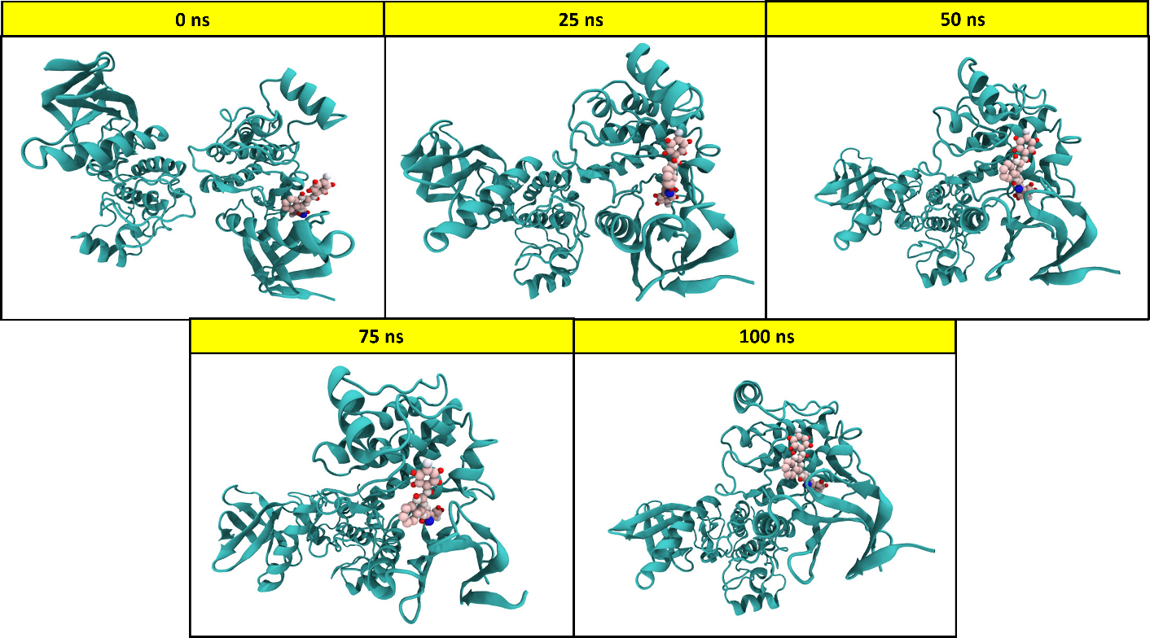

**Video S1:** [**https://drive.google.com/file/d/1Qf4_M827MvSCdClB_GPkRRc2ukrXARtK/view?usp=drivesdk**](https://drive.google.com/file/d/1Qf4_M827MvSCdClB_GPkRRc2ukrXARtK/view?usp=drivesdk)

**Analytical Supplementary Data**

**Chemistry: general procedures**

All starting materials, reagents and solvents were obtained from commercial suppliers and used without further purification. All reactions were monitored by thin-layer chromatography on 0.25 mm silica gel plates (60GF-254) and visualized with UV light, chloride ferric or iodine vapor. Melting points were determined on an electrothermal melting point apparatus without correction. IR spectra were recorded on Shimadzu (FTIR-8400S) series FT- instrument. GC-MS was determined on an Aglient-1100 series FTD/BID trap spectrometer. 1H NMR spectrums were obtained on a jeol 400 spectrometer (400 MHz). The chemical shifts are expressed in d values (parts per million) relative to tetramethylsilane (TMS) as internal standard. Significant 1H NMR data are reported in the following order: multiplicity (s, singlet; d, doublet; t, triplet; m, multiplet) number of protons.

**Synthetic procedure**

**Synthesis of 5-phenyl-1,3,4-thiadiazol-2-amine (II)**

A stirring mixture of benzoic acid (6.10 g, 50 mmol), N-aminothiourea (4.55 g, 50 mmol) and POCl3 (13 ml) was heated at 75 C for 0.5 h. After cooling down to room temperature, water (55 ml) was added. The reaction mixture was refluxed for 4h. After cooling, the mixture was basified to pH 8 by the dropwise addition of 50% NaOH solution under stirring. The precipitate was filtered and recrystallized from ethanol to yield 6.5 g of the target compound **II** as a brownish crystal.

**4-(5-amino-1,3,4-thiadiazol-2-yl) phenol (II-2)**

Compound **2** was synthesized following the procedure described in Section **(II)**

Yield 80%, mp: 226˚- 230˚C; IR (KBr) Vmax 3398, 3245, 3057, 1503, 663 cm-1

**5-(4-fluorophenyl)-1,3,4-thiadiazol-2-amine (II-4)**

Compound **4** was synthesized following the procedure described in Section **(II)**

Yield 75%, mp: 230˚- 240˚ C; IR (KBr) Vmax 3037, 2806, 2975, 1504, 1148 cm-1

**Quinazoline-2,4 (1H,3H)-dione (IV)**

Urea (460 mmol) was heated to melt, then 2-methylaminobenzoic acid (46 mmol) was added. The mixture was stirred for 5 h at 150˚C and then cooled to below 100˚C. Water (70 mL) was added to quench the reaction. The precipitated was collected and recrystallized in a mixed solution of acetone (10 mL) and water (100 mL) to afford compound IV as a white powder (5.25 g, 64.3%); mp 278– 279˚C. IR (KBr) Vmax 3301, 3114, 1607, 1673 cm-1

**2, 4-dichloroquinazoline (V)**

2,4-dichloroquinazoline was obtained by refluxing 10.0g (0.061 mole) of quinazoline-2,4(1H,3H)-dione(Benzoylene urea) in 14.2g(0.092 mole) of Phosphorous oxychloride with 7.4g(0.061mole)N,N-dimethylaniline at 108°C . The progress of the reaction was monitored by TLC (Eluent: ethyl acetate: hexane=8:2). After the completion, the reaction mass was cooled to room temperature and hence poured onto ice water under stirring. An off-white viscous precipitate formed. The resultant mass was basified with Aqueous 20% w/v of Potassium carbonate to pH 8.0. After reaching the mentioned pH, the reaction mass was extracted with 200.0 ml Dichloromethane. The dichloromethane layer was given a water wash, dried over sodium sulphate and hence distilled to obtain 5.0 g 2, 4- dichloroquinazoline. Melting point: 118-120°C. IR (KBr) Vmax 3142, 1588, 873, 765 cm-1

**N-(2-chloro-4a,8a-dihydroquinazolin-4-yl)-5-phenyl-1,3,4-thiadiazol-2-amine (VI)**

DIPEA (0.951ml, 5.3 mmol) was added to a suspension of 2,4 dichloo quinazoline (370 mg, 1.85 mmol) and 5-Phenyl-1,3,4-thiadiazol-2-amino (250mg,0.75mmol) in ethanol (10 ml). The Suspension was stirred at 25˚C for 24 hrs. The resulting precipitated was filtered and washed with ethanol to afford as white solid.

**4-(5-((2-chloroquinazolin-4-yl)amino)-1,3,4-thiadiazol-2-yl)phenol (VI-2)**

Compound **VI-2** was synthesized following the procedure described in Section **(VI)**

Yield 60%, mp:230˚-250˚C; IR (KBr) Vmax 3440, 3260, 3064, 1633, 760, 699 cm-1. GC-MS (m/z): calculated for C16H10ClN5OS is 355.80; found 355.00 (M+) and 357.00 (M+2)

**N-(2-chloroquinazolin-4-yl)-5-(4-fluorophenyl)-1,3,4-thiadiazol-2-amine (VI-4)**

Compound **VI-4** was synthesized following the procedure described in Section **(VI)**

Yield 65%, mp:245˚-255˚C; IR (KBr) Vmax 3401, 2930, 1520, 1273, 847, 642 cm-1. GC-MS (m/z): calculated for C16H9ClFN5S is 357.79; found: 357.00 (M+) and 359.00 (M+2)

**N2-(4-fluorophenyl)-N4-(5-phenyl-1,3,4-thiadiazol-2-yl)-4a,8a-dihydroquinazoline-2,4-diamine (VII)**

A mixture of VI (1-8) (24.3mg, 0.081mmol), and aniline derivatives (55.4mg, 0.416mmol) in ethanol (1.5 ml) was stirred at 120˚ C in a sealed vial for 1.5 h. and the reaction mixture was cooled and purified with suitable solvent.

**4-(5-((2-((4-fluorophenyl)amino)quinazolin-4-yl)amino)-1,3,4-thiadiazol-2-yl)phenol (VII-2d)**

Compound **2d** was synthesized following the procedure described in Section **(VII)**

Yield 52%, mp: 250˚-270˚C; IR (KBr) Vmax 3437, 3337, 3141, 1684, 1055, 690 cm-1; **1H NMR (DMSO-d6) δ ppm;** 5.45-5.59 (d, 2H, Quinazoline Ar-H), 6.61-6.67 (d, 2H, Quinazoline Ar-H), 7.91-7.60 (m, 4H, 4-Floroaniline Ar-H), 7.61-8..26 (m, 4H, Thiadiazole Ar-H), 10.90 (s, 1H, NH), 11.45 (s, 1H, NH), 12.00 (s, 1H, OH). **13CNMR (400MHz, DMSOd6, δ, ppm):** 102.09, 110.50, 111.81, 112.57, 116.34, 117.02, 119.67, 127.13, 131.36, 134.74, 144.70, 145.49, 154.16, 157.39, 159.70, 170.50, 175.51, 191.08 and 194.13. GC-MS (m/z): calculated for C22H17FN6OS is 432.47; found: 433.00 (M+1).

**N2-(4-fluorophenyl)-N4-(5-(4-fluorophenyl)-1,3,4-thiadiazol-2-yl)quinazoline-2,4-diamine (VII-4d)**

Compound **4d** was synthesized following the procedure described in Section **(VII)**

Yield 50%, mp: 240˚-270˚C; IR (KBr) Vmax 3433, 3190, 1583, 1062, 678 cm-1; **1H NMR (DMSO-d6) δ ppm;** 4.523-4.54 (d, 2H, Quinazoline Ar-H), 5.00-5.25 (m, 2H, Quinazoline Ar-H), 7.11-7.23 (d, 4H, 4-Floroaniline Ar-H), 8.13-8.68 (m, 4H, Thiadiazole Ar-H), 11.42 (s, 1H, NH), 11.66 (s, 1H, NH). **13CNMR (400MHz, DMSOd6, δ, ppm):** 102.09, 110.50, 111.81, 112.57, 114.15, 124.67, 126.45, 127.40, 127.82, 128.05, 128.46, 128.71, 133.44, 133.67, 134.19, 134.74, 144.70, 145.46, 153.26, 154.48, 159.92, 160.35, 191.22, and 194.55. GC-MS (m/z): calculated for C22H16F2N6S is 434.46; found: 434.00 (M+).

**Compound: 4-(5-amino-1,3,4-thiadiazol-2-yl) phenol (II-2)**



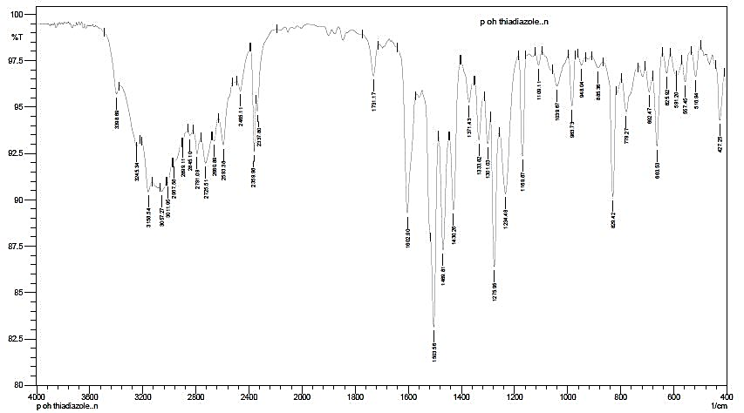

**Compound:5-(4-fluorophenyl)-1,3,4-thiadiazol-2-amine (II-4)**

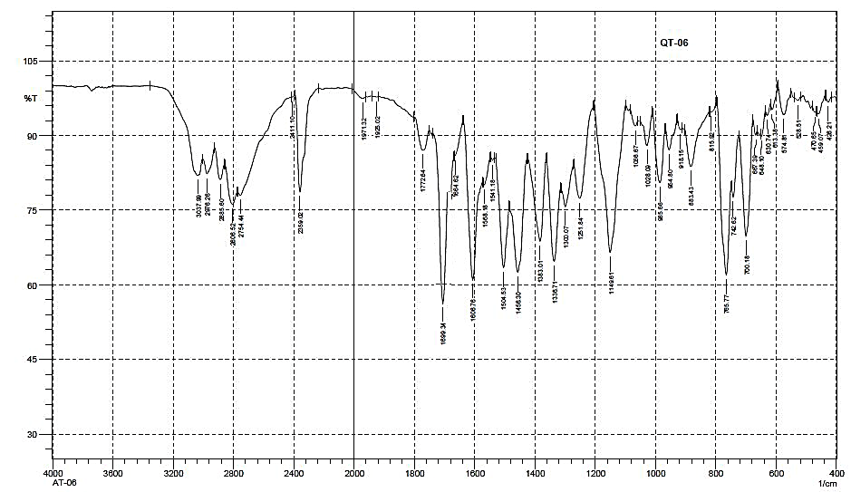

**Compound: Quinazoline-2,4 (1H,3H)-dione (IV)**



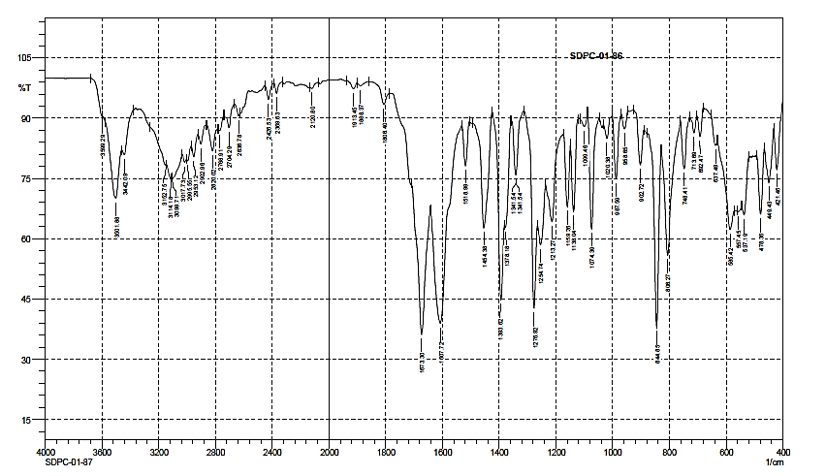

**Compound: 2, 4-dichloroquinazoline (V)**



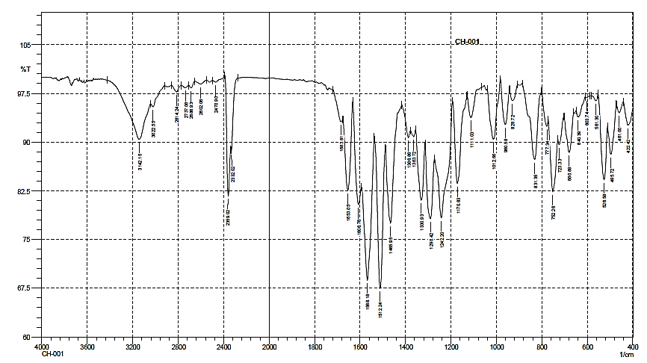

**Compound: 4-(5-((2-chloroquinazolin-4-yl)amino)-1,3,4-thiadiazol-2-yl)phenol (VI-2)**



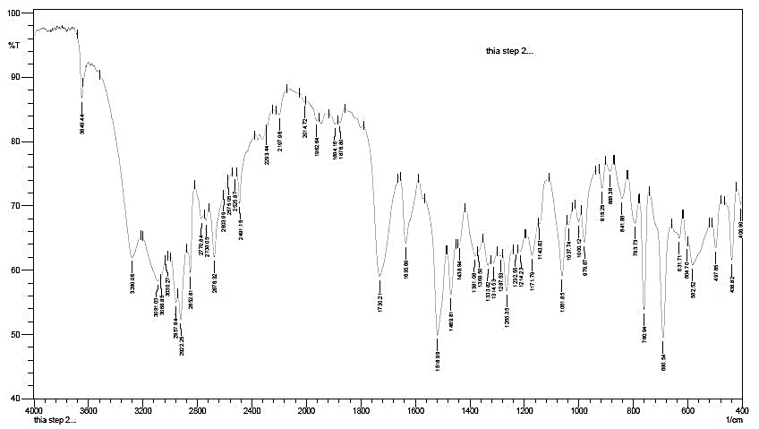

**Compound: 4-(5-((2-chloroquinazolin-4-yl)amino)-1,3,4-thiadiazol-2-yl)phenol (VI-2)**



**Compound: N-(2-chloroquinazolin-4-yl)-5-(4-fluorophenyl)-1,3,4-thiadiazol-2-amine (VI-4)**

 

**Compound: N-(2-chloroquinazolin-4-yl)-5-(4-fluorophenyl)-1,3,4-thiadiazol-2-amine (VI-4)**



**Compound:4-(5-((2-((4-fluorophenyl)amino)quinazolin-4-yl)amino)-1,3,4-thiadiazol-2-yl)phenol (VII-2d)**



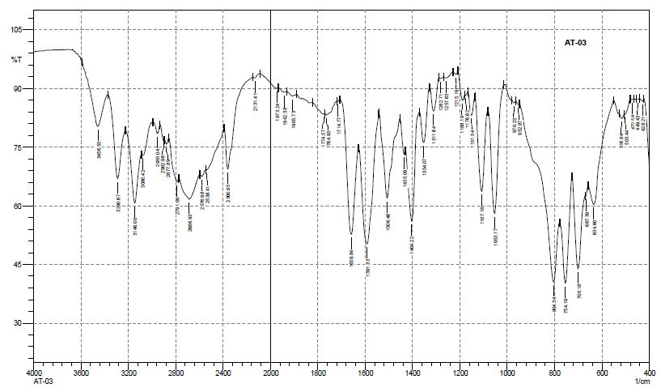

**Compound:4-(5-((2-((4-fluorophenyl)amino)quinazolin-4-yl)amino)-1,3,4-thiadiazol-2-yl)phenol (VII-2d)**

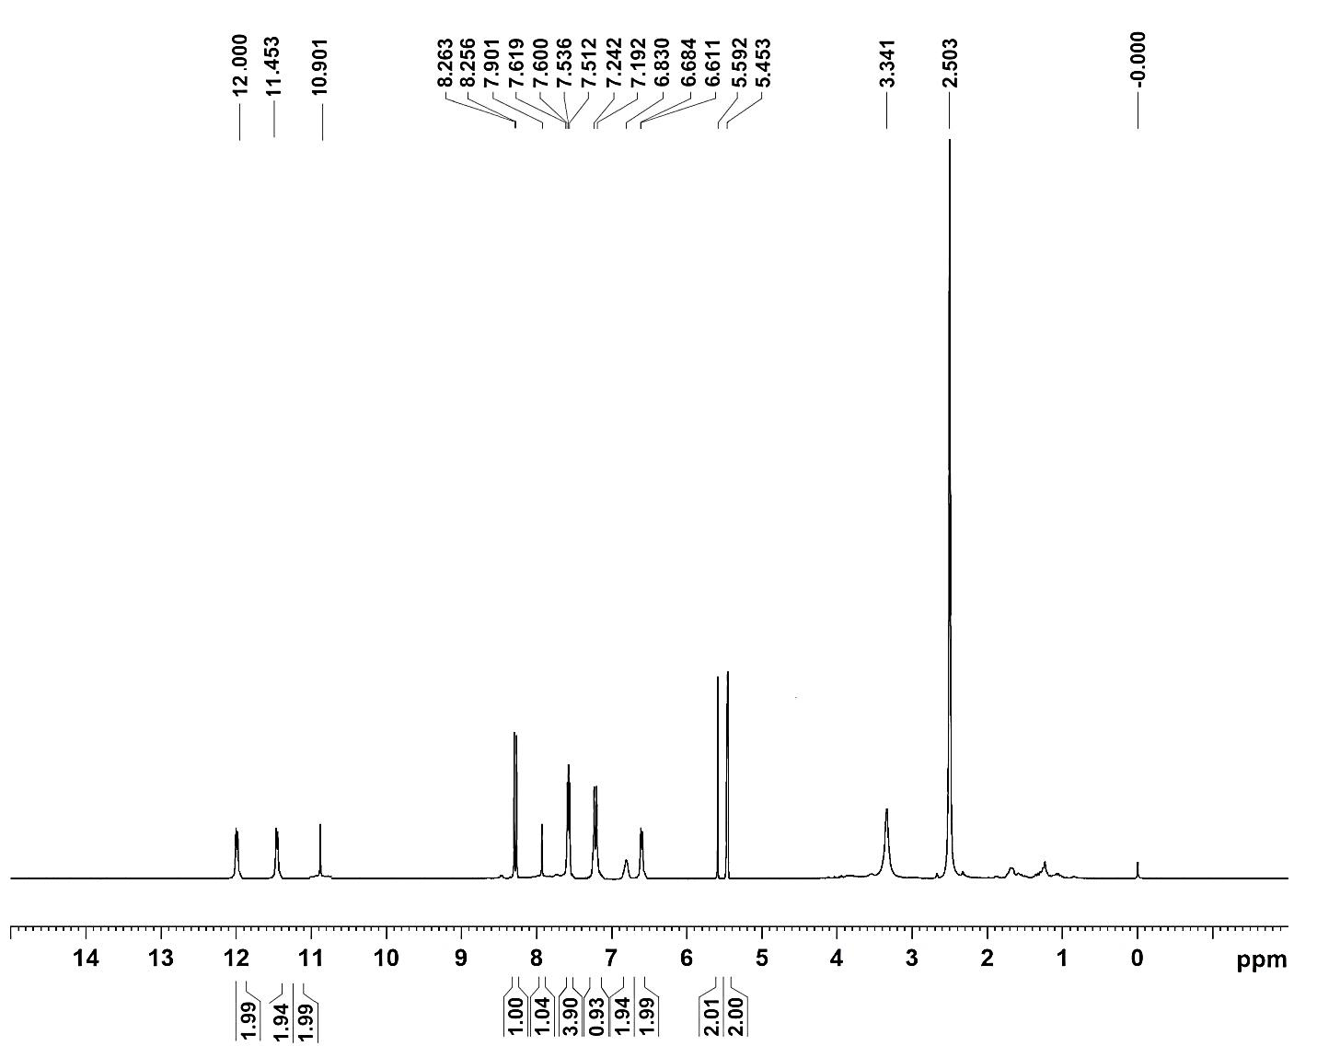

**Compound:4-(5-((2-((4-fluorophenyl)amino)quinazolin-4-yl)amino)-1,3,4-thiadiazol-2-yl)phenol (VII-2d)**



**Compound:4-(5-((2-((4-fluorophenyl)amino)quinazolin-4-yl)amino)-1,3,4-thiadiazol-2-yl)phenol (VII-2d)**



**Compound: N2-(4-fluorophenyl)-N4-(5-(4-fluorophenyl)-1,3,4-thiadiazol-2-yl)quinazoline-2,4-diamine (VII-4d)**



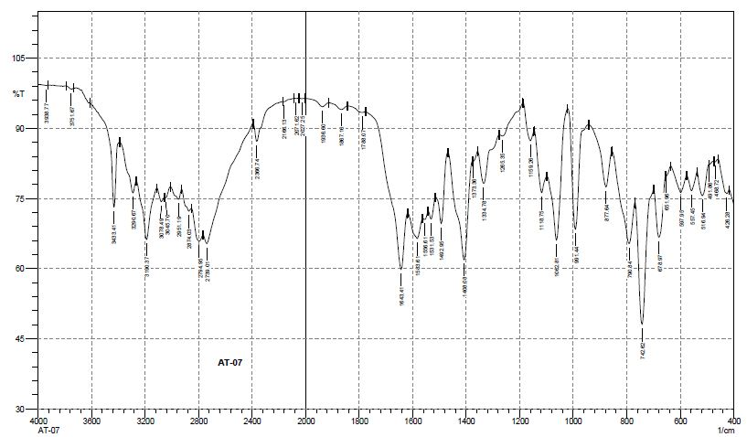

**Compound: N2-(4-fluorophenyl)-N4-(5-(4-fluorophenyl)-1,3,4-thiadiazol-2-yl)quinazoline-2,4-diamine (VII-4d)**



**Compound: N2-(4-fluorophenyl)-N4-(5-(4-fluorophenyl)-1,3,4-thiadiazol-2-yl)quinazoline-2,4-diamine (VII-4d)**



**Compound: N2-(4-fluorophenyl)-N4-(5-(4-fluorophenyl)-1,3,4-thiadiazol-2-yl)quinazoline-2,4-diamine (VII-4d)**

